Keegan Moynahan

Lab 3

\*\* Worked on Lab with Steph\*\*

1. Basal area is the measure of tree density. It is measured by BA= F\*DBH^2\*N Ba= Basal Area, F= Forester’s constant (.005454) DBH= average diameter of tree, N=trees per acre
2. Diagram

   Description automatically generated

1. Gray Jay birds seem to enjoy areas of lower Basal area. This can be shown by the graph above because the areas of Gray Jays being spotted are around the lower values of Basal area. This model seems like a good fit for the relation between Gray Jays and Basal area because it shows the negative correlation (most of the observed birds in lower basal area, shown by the downhill slope of the line) when the Basal area increase. The logistical model fits this data well because of the tapered observations and then the drop off to no observations.
2. 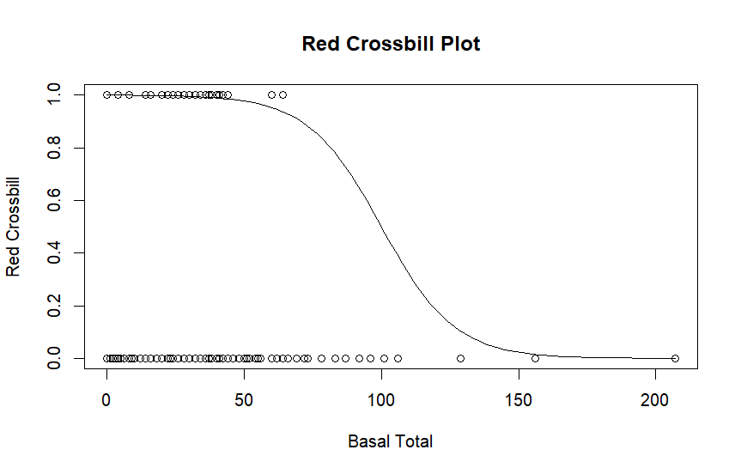
3. Red Crossbill birds seem to enjoy lower basal area as well, but there is evidence that there are Red Crossbill birds that enjoy higher basal area. Compared to Gray Jay birds these birds seem to enjoy higher basal area. This model fits also because it also shows that most of these birds enjoy lower basal area, this line in the model is less steep because of some outliers.
4. There were 181 Gray Jays observed in all the sampling sites.
5. 
6. There were 110 sampling sites that Gray Jays where observed in.
7. 